FRMS QGIS packaging overview

# FRMS application release process

The full FRMS application release process from source code to installation packages is shown in the enclosed diagram.

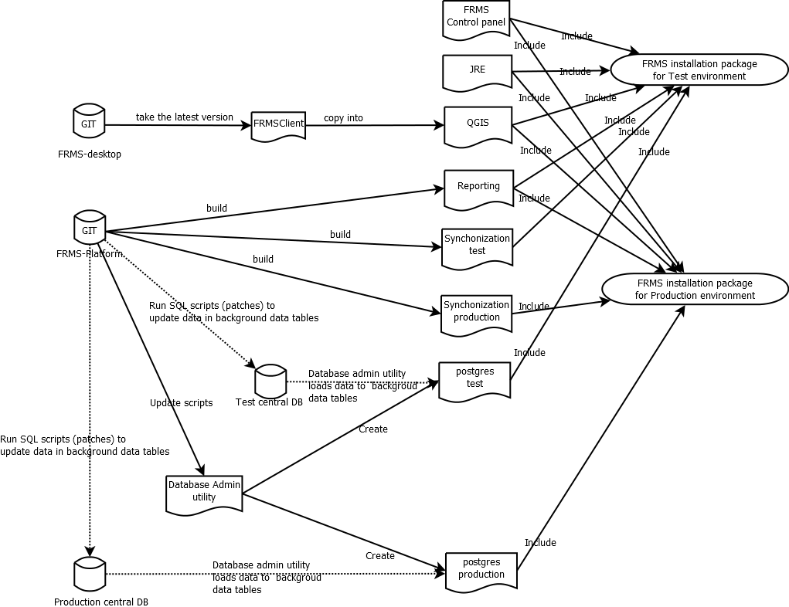

These instructions assume that each module is already build by the SW consultant or your in-house development team developing FRMS modules.

Note that you need to prepare separate installation package for each environment (central database)

# FRMS Installation package structure

FRMS application contains the following modules:

* FRMS Control panel
* JRE (Java runtime environment)
* QGIS (Quantum GIS) with FRMSClient python extension
* Reporting
* Synchronization
* Postgres (PostgreSQL) database

Every module is installed into it’s own subdirectory in the root directory of FRMS application, except FRMS control panel, which has files also in root directory of FRMS application.

Creation of FRMS installation package is basically installing all FRMS application components to the FRMS root directory and then creating the zip file from the FRMS root directory.

When all modules are installed to FRMS root directory it should look like this:

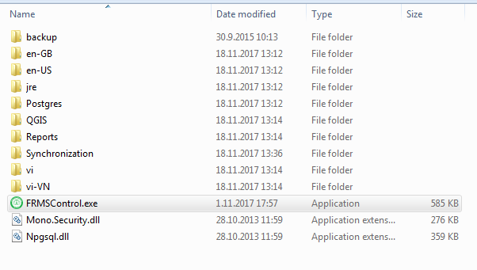

# Database admin tool

Database admin tool is a separate tool for the use of IT support personnel creating the FRMS installation package. It is used to setup the local database for FRMS installation package. Database-admin tool creates the FRMS data model to the Postgres database and reads the static background data from the central database, so the static data is already in the database and does no need to be replicated in initial load.

Database-admin scripts are maintained in frms-platfrom GIT repository in datamodel directory.

# Creating FRMS installation package

## Prepare Local database with database admin tool

FRMS local database is dependent on the FRMS central database as the static background data is downloaded from central database to local database when the local database is created for FRMS installation package.

Local database creation for FRMS installation package is done in three phases

1. Installation of database admin tool
2. Configuration of database admin tool
3. Building the local database with database admin tool

#### Installation of database admin tool

Unzip the database admin tool installation package into the computer.

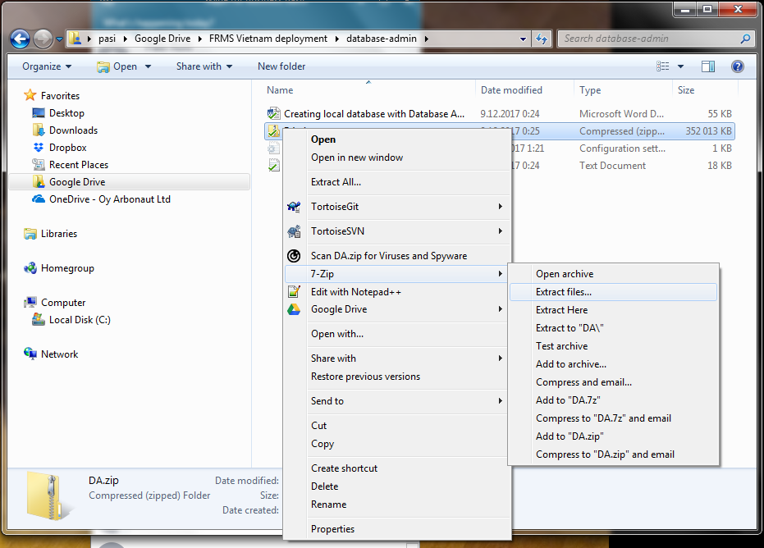

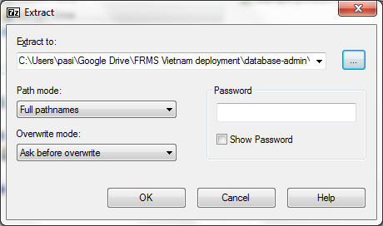

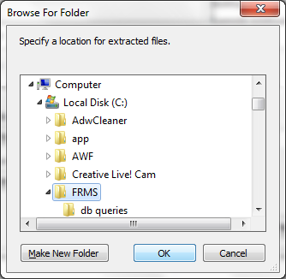  
  
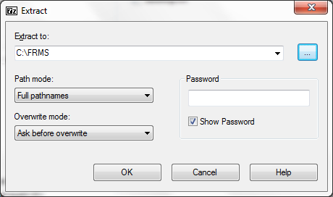

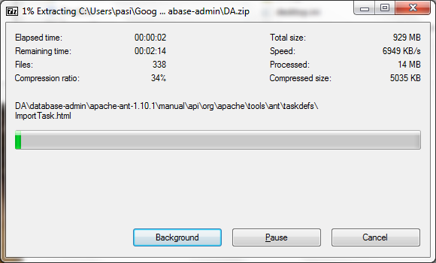

#### Configure the database admin tool

1. Go to DA\Database-admin\datamodel directory
2. remove the build, clean and original directories there  
   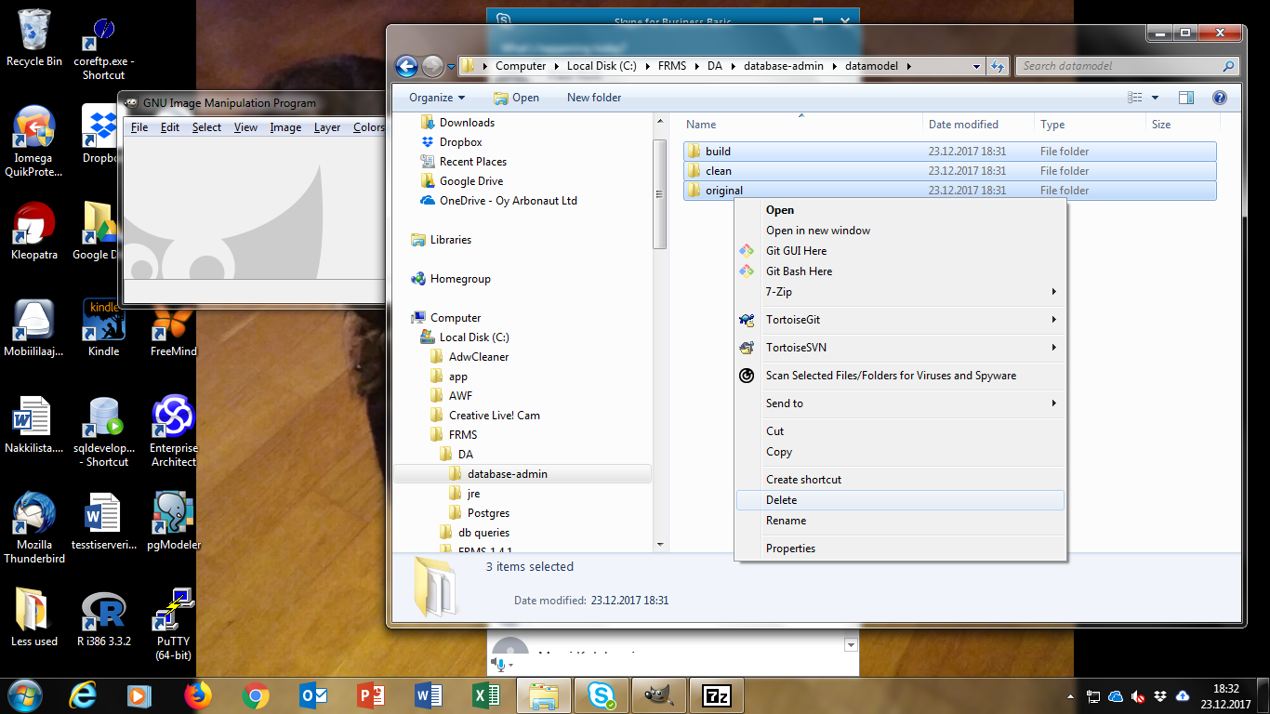  
   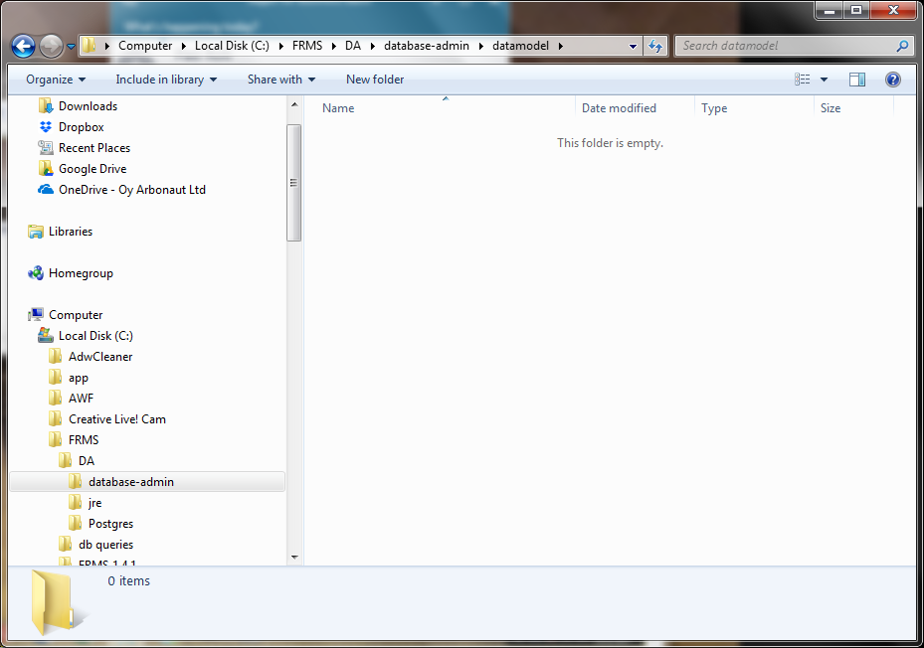
3. Copy frms-platform\datamodel\build directory from GIT repository to DA\ Database-admin\datamodel directory
4. Copy frms-platform\datamodel\clean directory from GIT repository to DA\Database-admin\datamodel directory
5. Copy frms-platform\datamodel\original directory from GIT repository to DA\Database-admin\datamodel directory  
   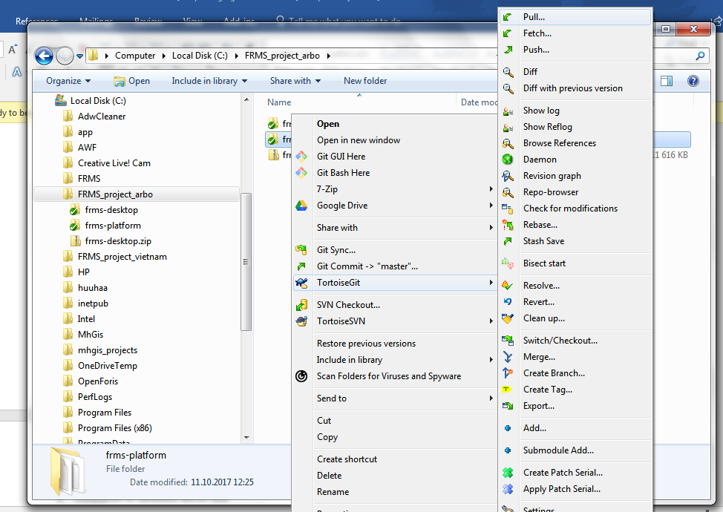  
   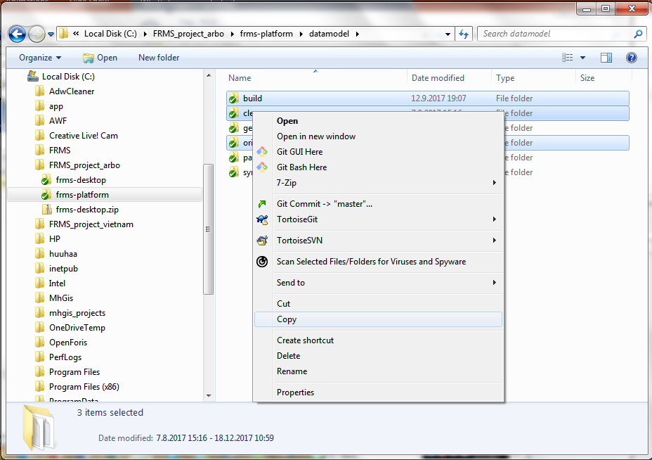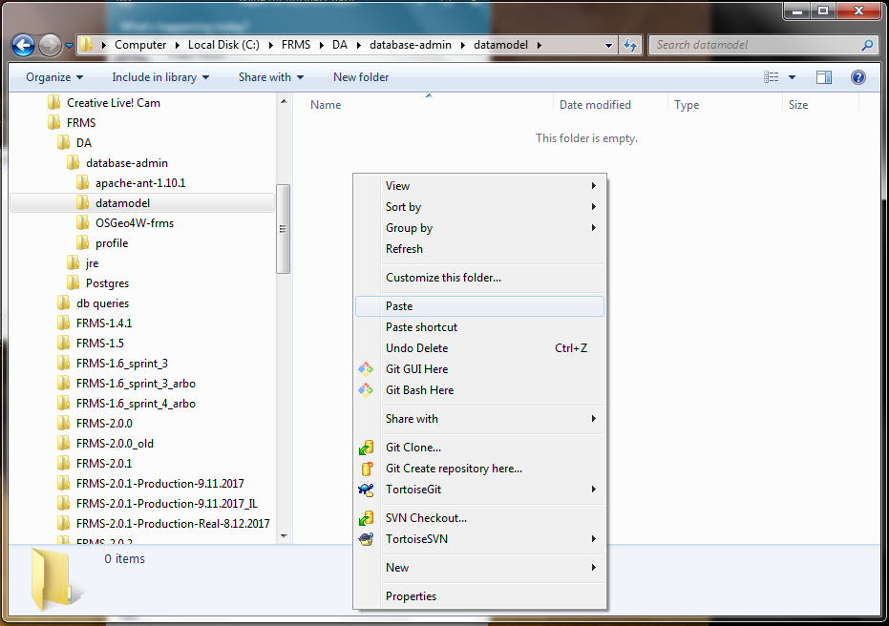  
   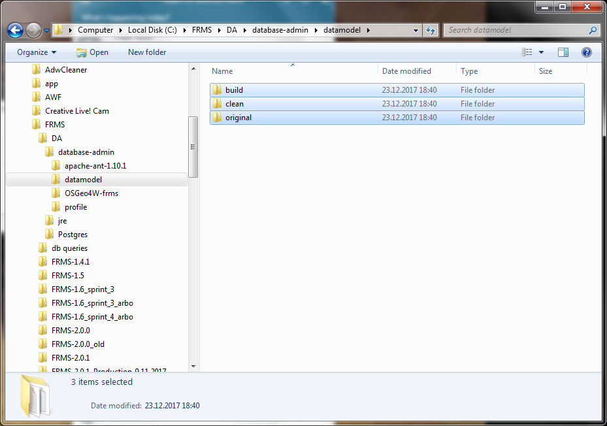
6. Edit the following settings in DA\Database-admin\profile\devenv.bat for your environment  
   SET FRMS_LOCALDB_USERNAME=

SET FRMS_LOCALDB_PASSWORD=

SET FRMS_LOCALDB_DATABASE=

SET FRMS_LOCALDB_PORT=5433

SET FRMS_CENTRALDB_USERNAME=

SET FRMS_CENTRALDB_PASSWORD=

SET FRMS_CENTRALDB_DATABASE=

SET FRMS_CENTRALDB_HOST=

SET FRMS_CENTRALDB_PORT=5433  
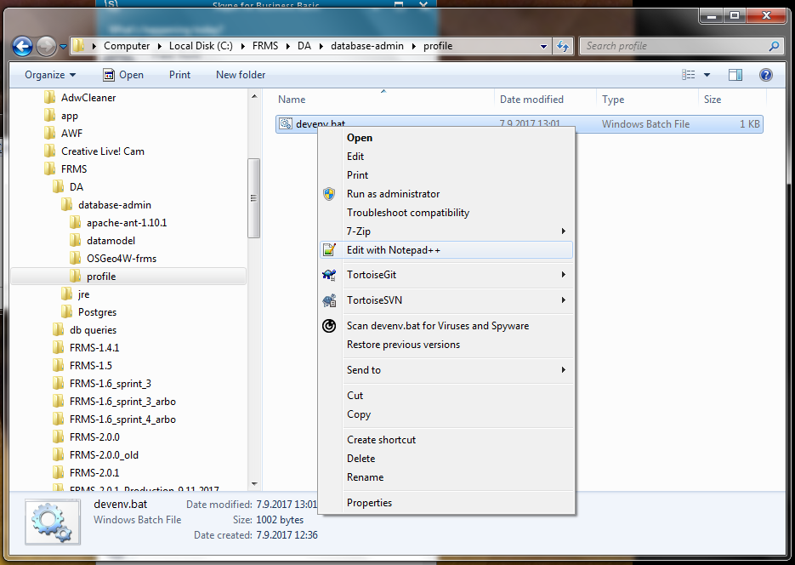  
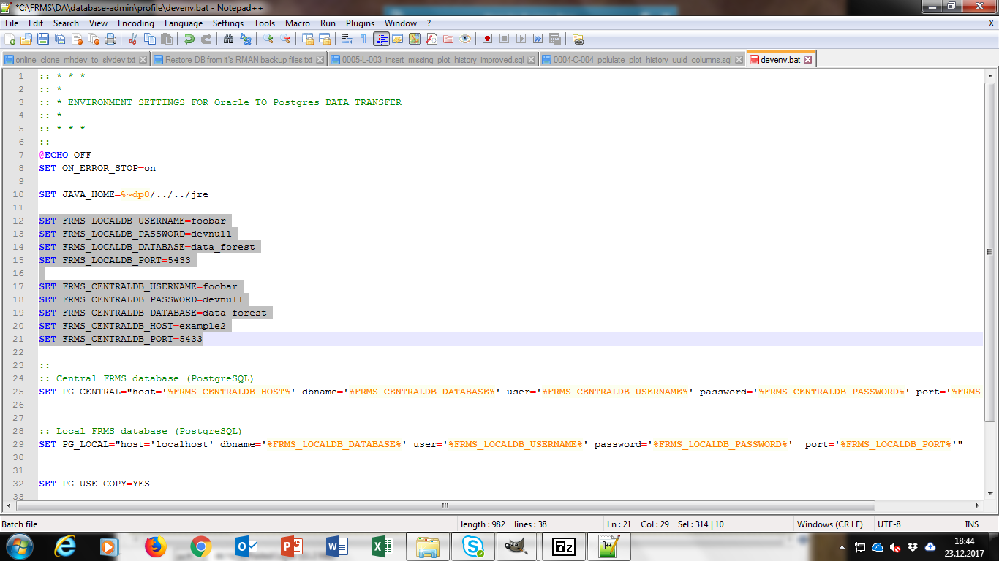

### Build the local database with Database admin tool

1. Open command prompt to DA\postgres directory  
   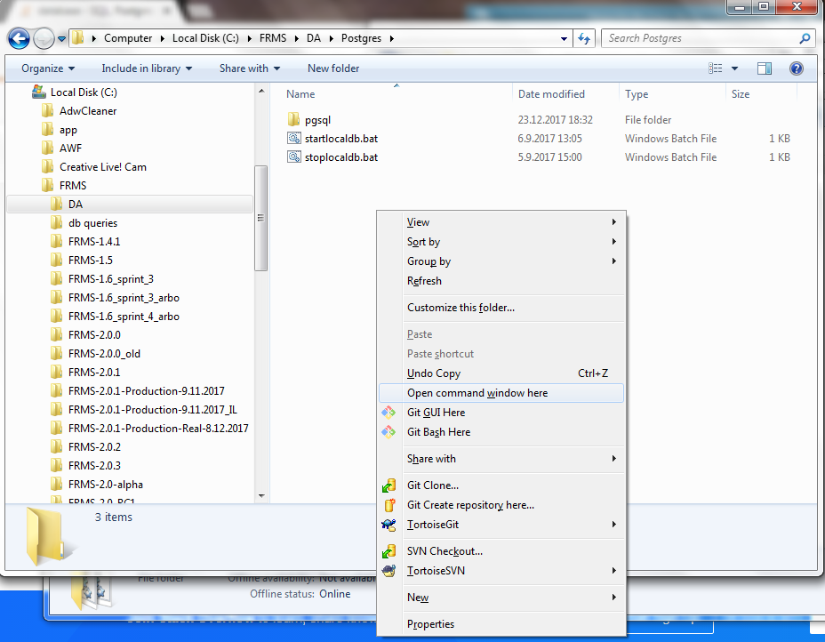
2. Ensure that no postgres instances are running on the host by running stoplocaldb.bat  
   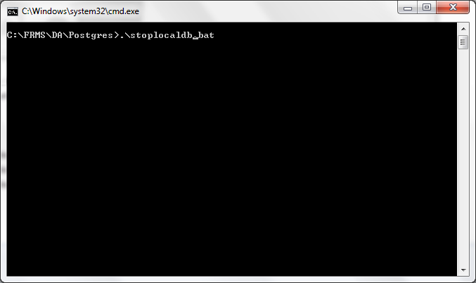
3. Start local database by running startlocaldb.bat  
   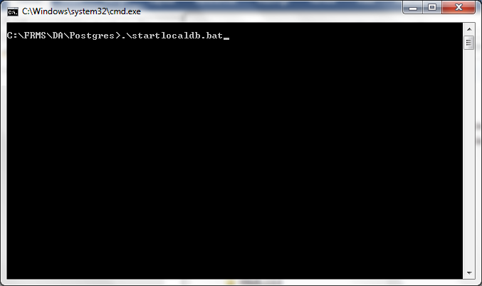
4. Open command prompt to DA\database-admin directory  
   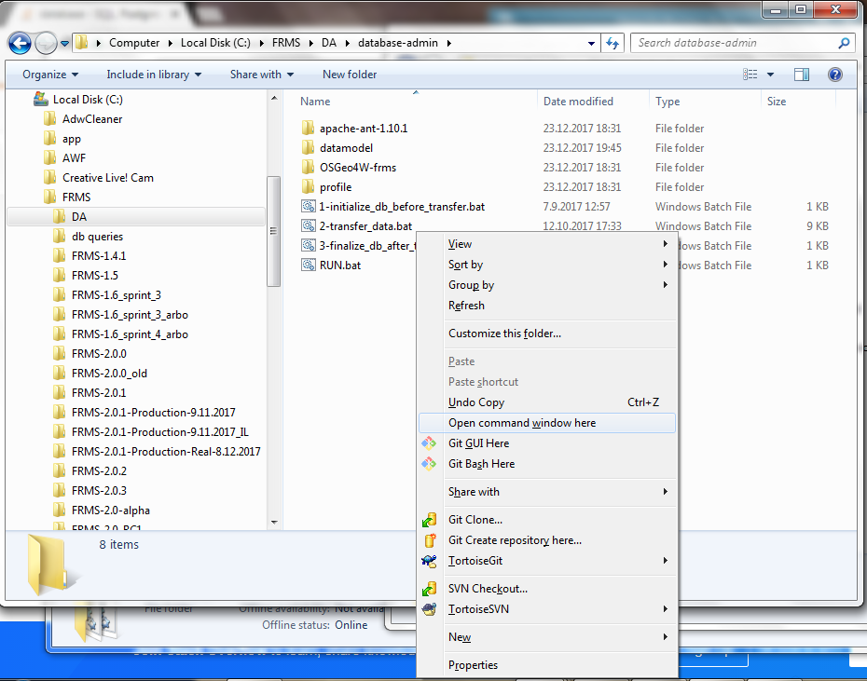
5. run database-admin by running run.bat  
   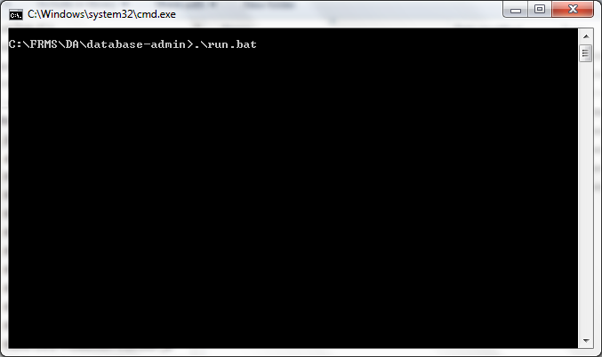
6. data-base admin is building a local database. Look that script does not give any error messages. an example of successful database-admin run is in [..\Data model\Example printout from successful Database admin run.txt](../Data%20model/Example%20printout%20from%20successful%20Database%20admin%20run.txt)
7. After database-admin has finished, stop local db by going to command prompt you opened in step 7 and running stoplocaldb.bat  
   

## Create FRMS root

Creation of FRMS installation package is started by creating a FRMS root directory. It is recommended to name the root directory to be the same as FRMS release name is eq. if you are building a installation package for FRMS-2.0.2 you create directory FRMS-2.0.2.

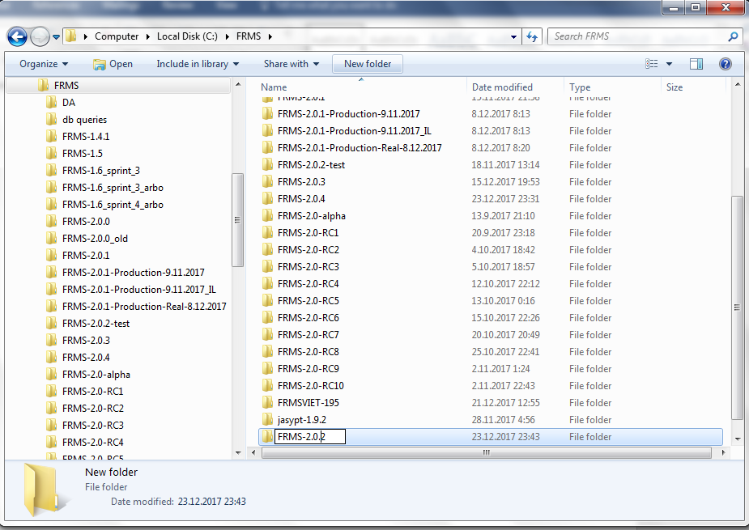

## Installing FRMS modules

After the root directory of FRMS release is created , the next steps are to install FRMS modules in it. Individual FRMS modules are delivered to you by SW vendor or your own development team in zip packages which you unzip to FRMS root directory

Installation procedure varies module by module and the installation procedure for each module Is described in next chapters.  
In the following examples <FRMScroot directory> = C:\FRMS\FRMS-2.0.2

### FRMS Control panel

<thao to add information on where the FRMS control panel is source code is kept>

Unzip the FRMS control panel package to FRMS root directory

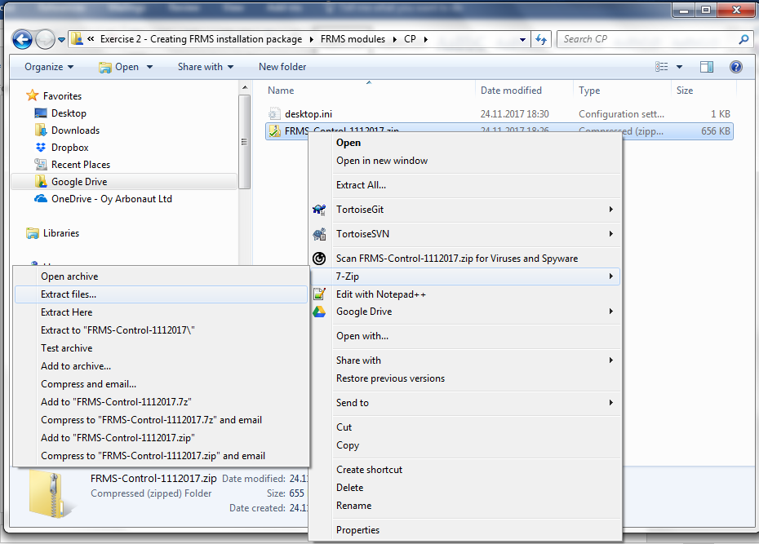

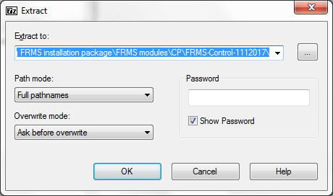  
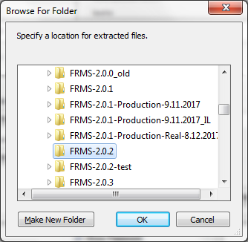  
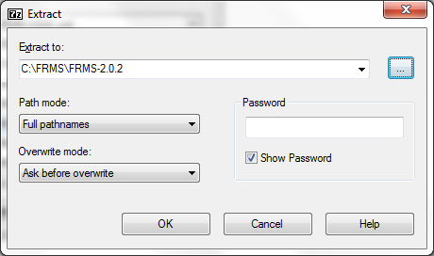

### JRE

FRMS uses standalone Java Runtime engine package. Unzip the JRE to FRMS directory

### QGIS

Installation of the QGIS in done in two phases. First install a standalone QGIS by unzipping the QGIS installation package to FRMS root directory  
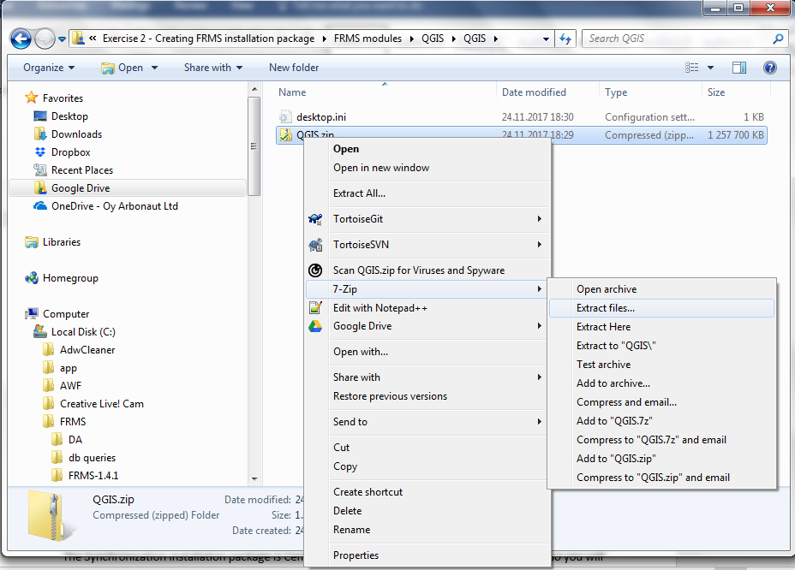  
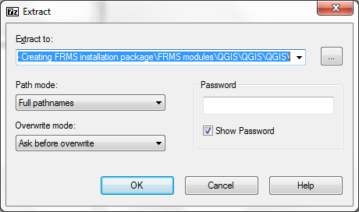  
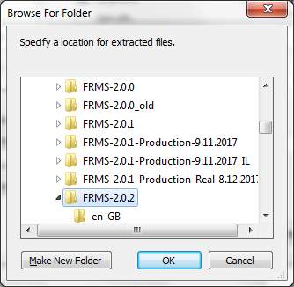  
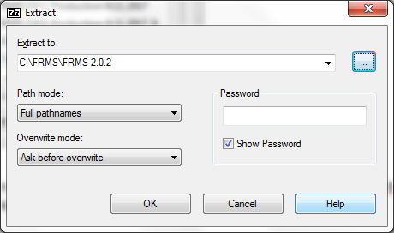  
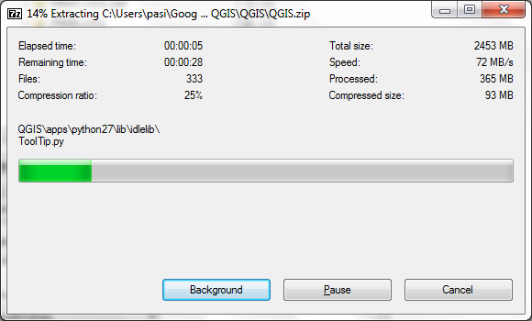

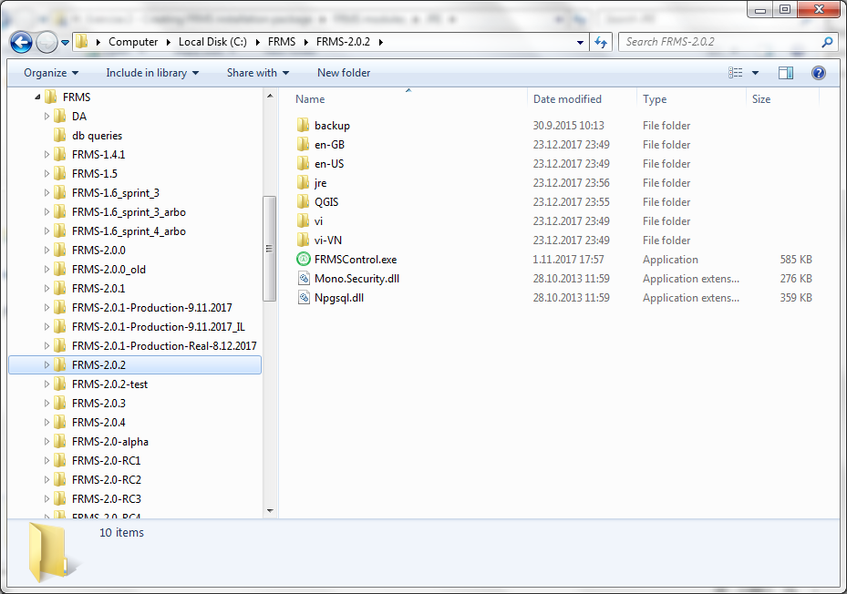

After the QGIS installation is ready, install the FRMSClient QGIS plugin by unzipping the FRMSClient installation package into <FRMS root directory>\QGIS\qgisconfig\python\plugins directory.  
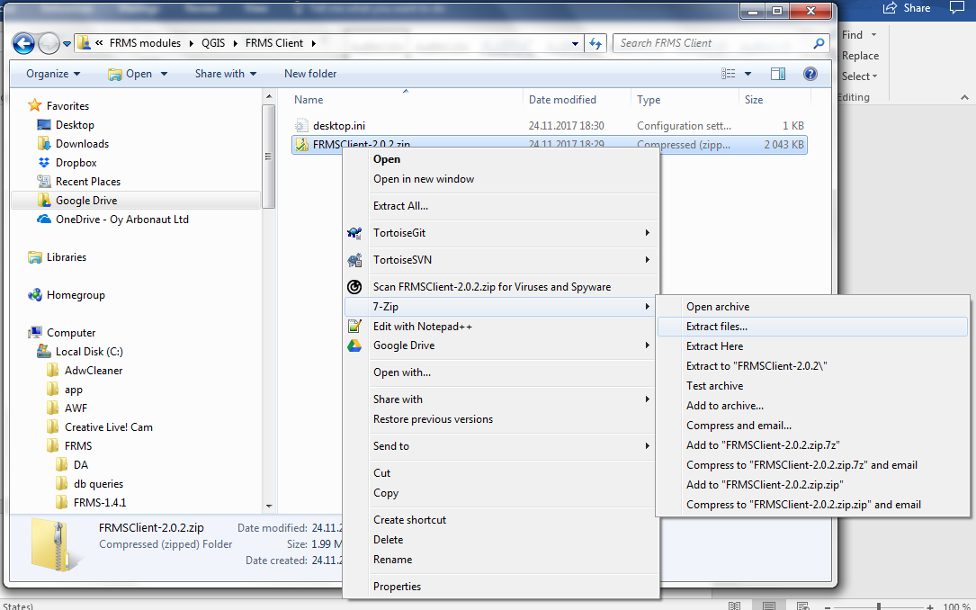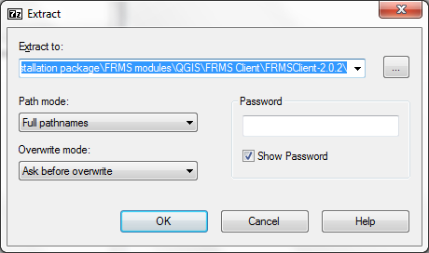  
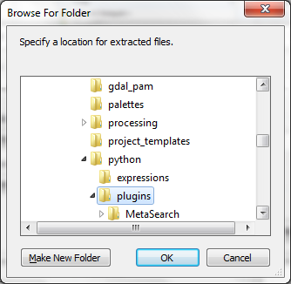  
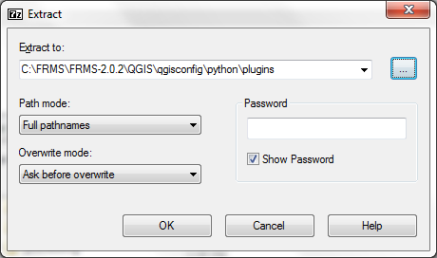

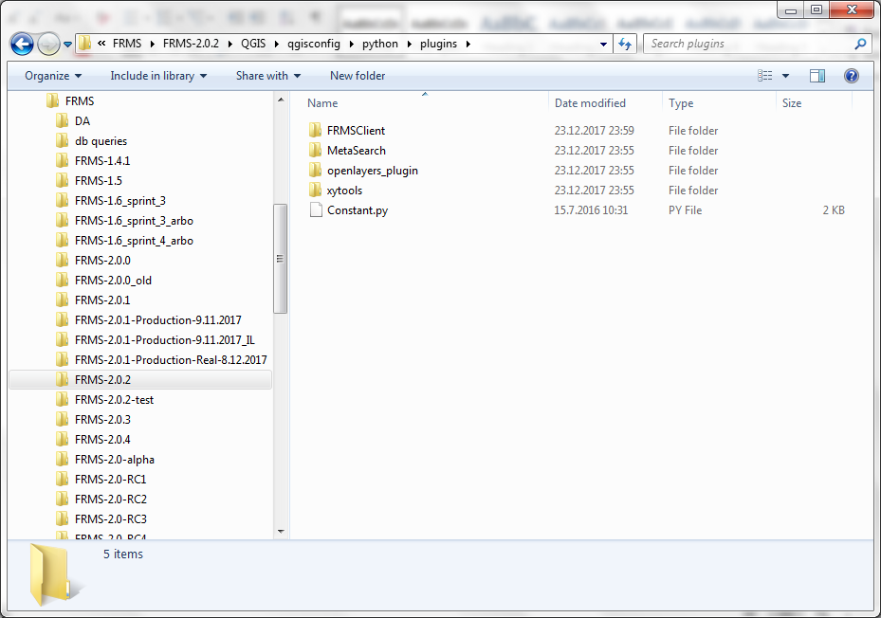

### Reporting

Install reporting module by unzipping the reporting installation package to FRMS root directory

### Synchronization

The Synchronization installation package is Central database and Symmetric server dependent, so you will have a different installation package for test environment and production environment. The installation of reporting module is done by unzipping the reporting installation package to FRMS root directory.

### Postgres (local database)

Install local database by copying DA\postgres directory to FRMS root directory

## Create FRMS installation package

Now you have all FRMS modules installed in to FRMS root directory and the directory structure looks like the following:



The only thing left is to create a zip package from FRMS root directory and deliver it to the end users